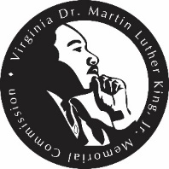



**Tribute to Senator Yvonne Miller Work Group**

Virginia Dr. Martin Luther King, Jr. Memorial Commission

**________________________________________**

House Room A, Room 008, General Assembly Building

**December 16, 2024**

**12:00 p.m.**

**AGENDA**

1. **Call to Order**
2. **Introduction of Members**
3. **Project Proposals**
4. **Recommendations to the Full Commission**
5. Other Business
6. Adjournment

**Members of the Work Group**

|  |  |
| --- | --- |
| Senator Mamie E. Locke, *Work Group Chair*  Delegate Alex Q. Askew  Delegate Betsy B. Carr  Senator Adam P. Ebbin | Louise Lockett Gordon  Kirk T. Schroder, J.D., Ph.D.  Dr. Karen Turner Ward |